Analysis of Bee Mortality during Winter 2025-2026

Report: April 2025
Authors: Mingtong Zhang, University of Amsterdam
Supervision: Suzan van der Post, University of Amsterdam

On behalf of:
Sonne Copijn, Bee Foundation
Casper Baan, Nederlandse Bijenhouders Vereniging

Executive Summary & Key Findings
This report analyzes honeybee winter mortality in the Netherlands for the 2025–2026 season, drawing from 832 apiaries and 4,846 hives. The data highlights critical insights into how beekeeping practices impact colony survival:
- High winter mortality: The overall winter mortality rate is 21.69%, meaning more than one in five hives did not survive the winter. This is more than double the ‘normal’ baseline of 10%.
- Feeding only honey in winter becomes a risk: Hives fed exclusively on their own honey experienced a strikingly high mortality rate of 41.12%. However, supplementing honey with sugar water significantly mitigates this risk, bringing mortality down to around 20%.
- The importance of varroa treatment: Proper treatment is highly effective. Full interventions, such as the ‘3-gangenmenu’ or alternative complete treatments, resulted in the lowest mortality rates (19.15% and 13.43%, respectively). Even for hives fed exclusively on honey, applying the "3-gangenmenu" treatment drastically reduced mortality from 45.4% to 16.3%.
- ‘Not seeing’ does not mean ‘not existing’: Beekeepers who reported not observing varroa mites or Asian hornets actually experienced the highest colony mortality rates (31.23% and 29.82%, respectively). This suggests that invisible or unnoticed threats are highly damaging.
- ‘Regulier’ beekeeping method turns out to be the most risky method: While natural beekeeping methods initially appear to have higher mortality (27.56%) , this is largely driven by their tendency to rely solely on honey feed and avoid varroa treatments. When all the other variables are controlled, the regulier (regular) beekeeping method intrinsically carries a 50.81% higher mortality risk compared to the controlled methods, such as aalster and renson method.

1. Introduction & Data Overview
The survey was conducted between January 20 and April 7, 2026. It asked beekeepers to review the 2025~2026 beekeeping year and answer questions including number of hives in each season, beekeeping practices, and observed changes. A total of 844 responses were collected from 706 beekeepers, representing 844 apiaries (bijenstanden). We excluded locations outside the Netherlands (3) and those showing abnormal ‘winter growth’ (9).
After data cleansing, 832 apiaries from 695 beekeepers remained for the final analysis. Among which, there are the exact GPS locations from 427 apiaries. The self-reported data from beekeepers shows a winter mortality rate of 21.69%.
Based on data self-reported by the beekeepers, we have identified 4846 hives in total at the beginning of winter from the survey. In comparison, the Dutch Beekeeping Association (NBV) has given an estimation of a total of 80,000 - 100,000 beehives in The Netherlands, which suggests our survey has roughly covered 5% of the total population. Indeed this dataset may carry inherent self-selection bias, but it still provides a valuable snapshot of the honeybee health status in the Netherlands for the 2025-2026 beekeeping season.

2. Overview of Winter Mortality Rate
Among the 695 beekeepers, 322 (46.33%) beekeepers have zero death during winter, and the other 373 (53.67%) beekeepers have experienced mortality.
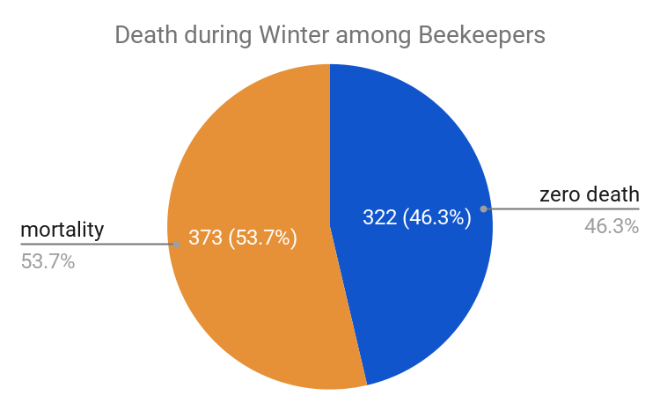
For apiaries, 402 (48.32%) apiaries did not show any mortality during the winter, whereas 430 (51.68%) apiaries experienced a different degree of mortality. Later we will analyse if bees die in the same locations each year (2023-2026).
Based on data self-reported by the beekeepers, we have identified 4846 hives in total at the beginning of winter from the survey, among which 3795 survived and 1051 died. The winter mortality rate is 21.69%.
In comparison, last year, our survey showed a mortality rate of 21.62% during the winter, of which 43.32% (81) of the apiaries experienced mortality.

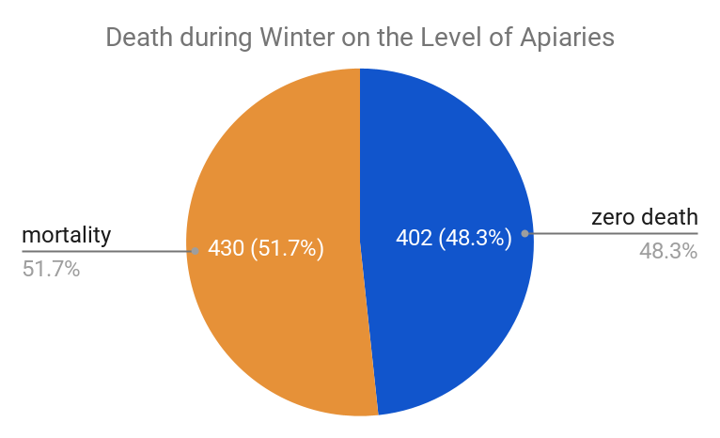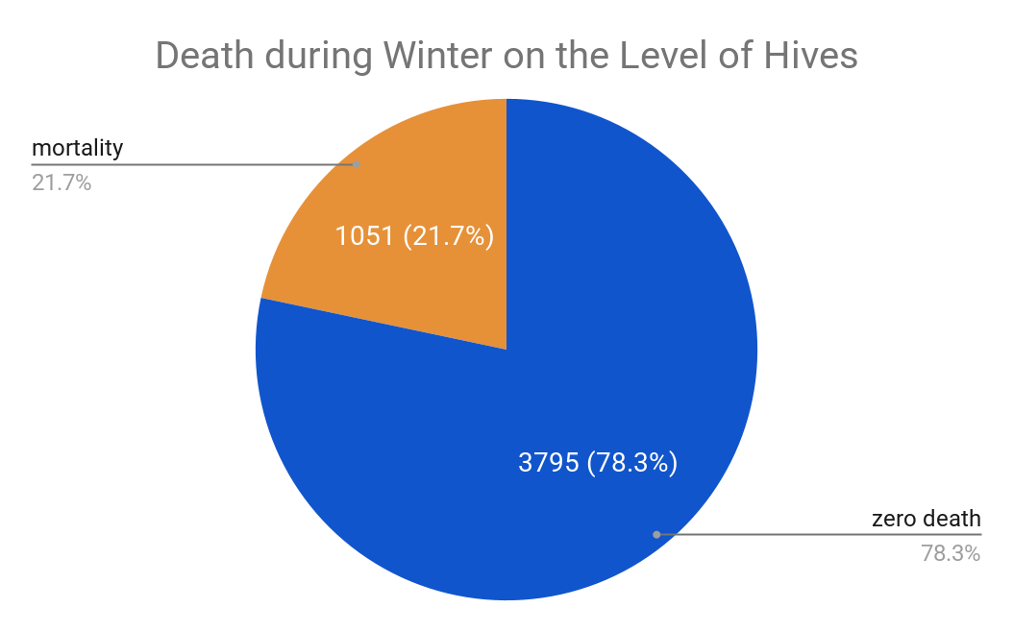

Over the past ten years, bee winter mortality in the Netherlands has shown significant fluctuations but remains alarmingly high compared to historical norms. The death rate since 2020 has remained consistently above 15%. Compared to baseline, the 2026 winter mortality rate of 21.69% continues to exceed the 10% 'normal death rate threshold’, remaining at a level that is more than double the acceptable baseline.

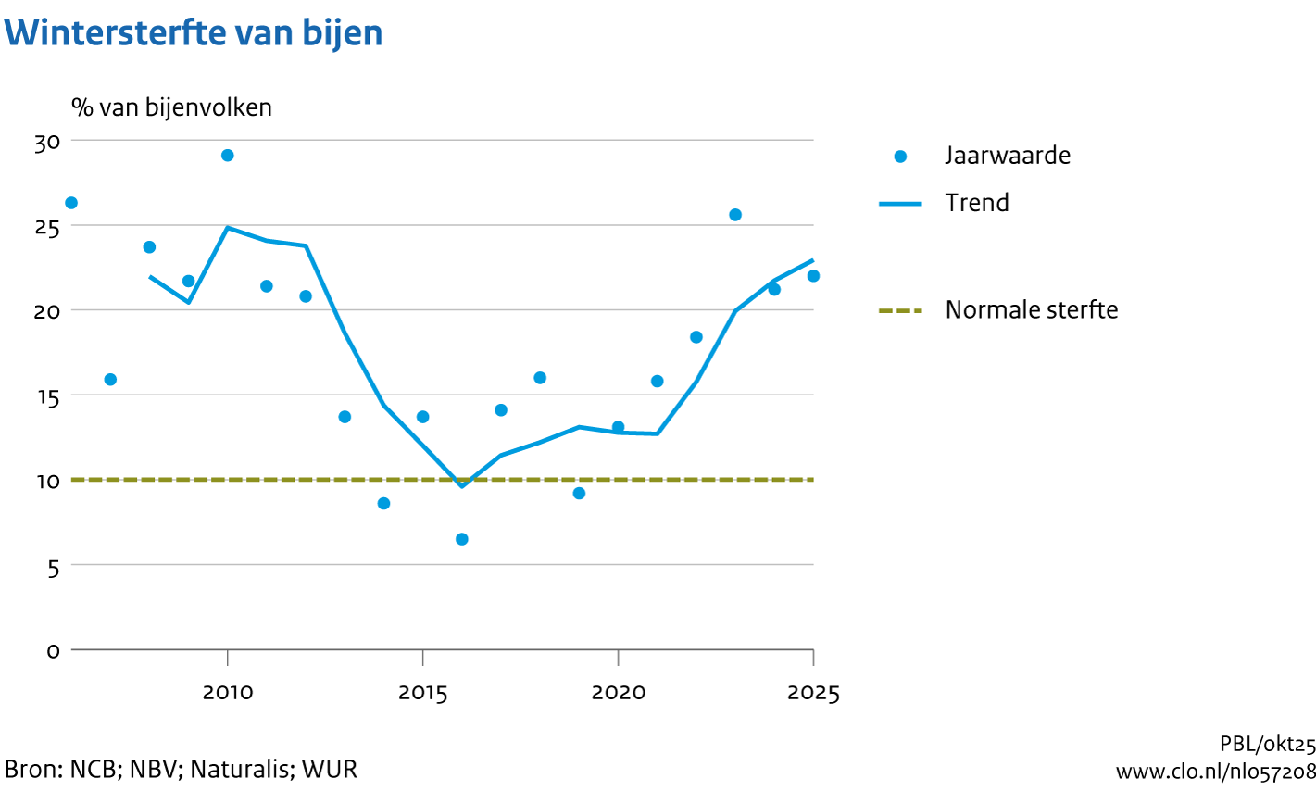

For each province, the mortality rate shows a high variance. However, as some provinces only cover a small number of hives and locations, the mortality rate here should only be understood as a descriptive result, but not representative , therefore the difference between provinces should not be used for direct comparison.

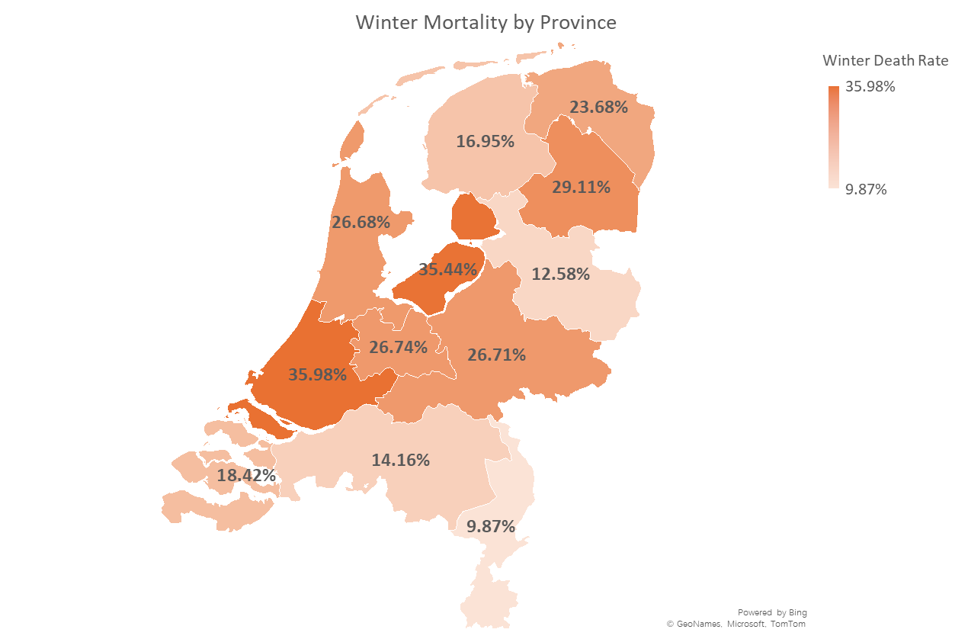

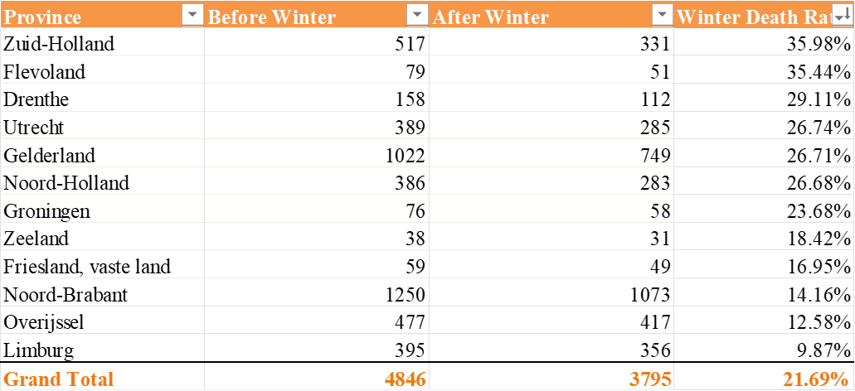

3. Overview of the survey results
This section provides a descriptive summary of the beekeepers' self-reported practices, observations, and colony developments during the 2025-2026 beekeeping year. The data represents feedback from the final sample of 832 apiaries.

3.1. Beekeeping Method (Welke imkermethode hanteer je?)
Beekeepers were asked to identify their primary beekeeping method. The majority of the apiaries (55%) are managed using regular (regulier) methods. Approximately 23% employ mixed or unspecified methods, whereas natural (12%) and controlled (10%) methods constitute a smaller portion of the overall beekeeping methods.

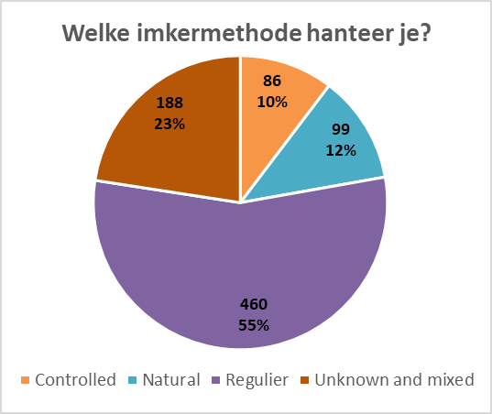

3.2. Winter Feed (Hoe heb je de bijen ingewinterd?)
When preparing for winter, nearly two-thirds of the apiaries (65%) were fed a combination of their own honey and supplementary sugar water. Around 21% were fed exclusively on sugar water, and 14% were wintered entirely on their own honey reserves.

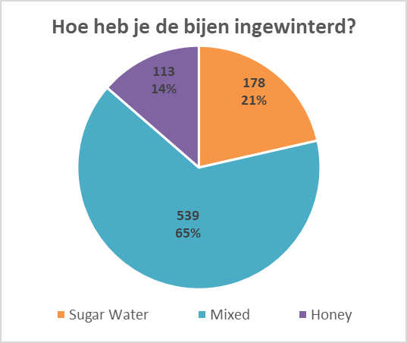

3.3. Varroa Treatment (Zijn de bijen het afgelopen jaar tegen varroamijt behandeld?)
The most prevalent varroa treatment strategy was the complete '3-course menu' (3-gangenmenu), applied in nearly half (48%) of the recorded apiaries. Conversely, 17% of apiaries received no varroa treatment at all. Partial treatments in winter (14%) or summer (11%), and alternative complete treatments (10%) made up the remainder of the strategies.

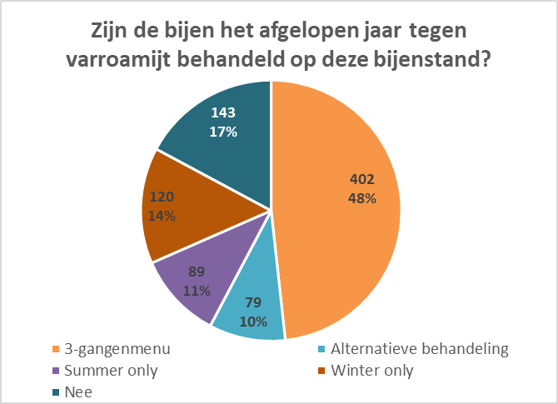

3.4. Colony Development in Spring and Summer 2025
Beekeepers overwhelmingly reported positive colony development during the spring and summer of 2025. A significant majority (88%) rated the development as 'good' (goed). Only a small fraction experienced moderate (9%) or bad (1%) colony development.

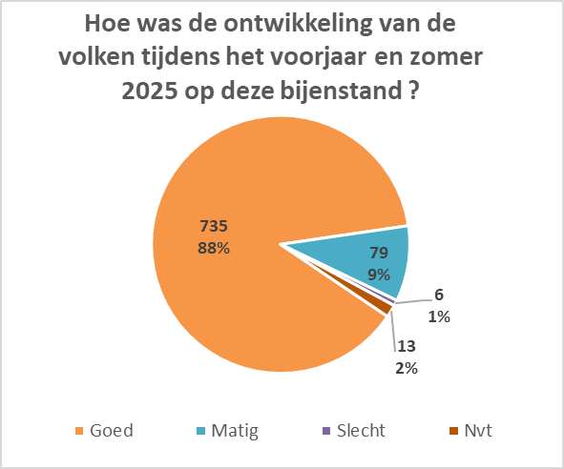

3.5. Observed Varroa Mites
Observations of varroa mites within the apiaries were widespread. The largest group of apiaries (41%) reported a moderate (matig) presence, while 30% reported a low (weinig) presence. About 9% observed a high (veel) varroa load. Notably, 12% reported not seeing any varroa mites, though later analysis indicates this does not necessarily equate to an absence of risk.
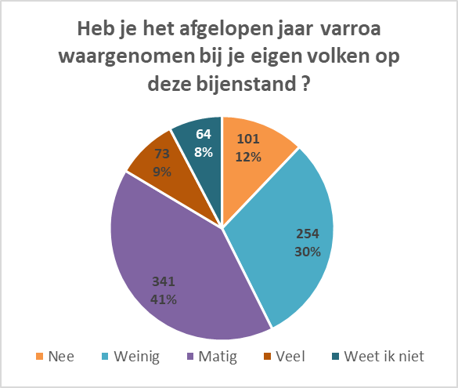

3.6. Observed Asian Hornet
The Asian hornet remains a visible threat for a significant portion of beekeepers. While 40% did not observe any Asian hornets near their apiaries, a combined 35% observed moderate (18%) to high (17%) frequencies. Another 23% noted a low (weinig) presence of the predator
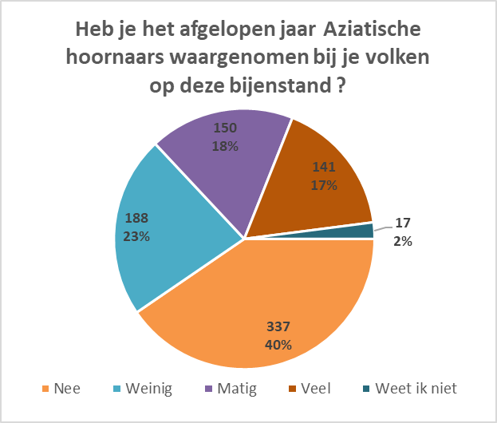

3.7. Observed Deformed Wing Virus
Deformed Wing Virus was not visibly apparent in the vast majority of cases, with 79% of responses indicating no observation. Minor infections were spotted in 11% of apiaries, and moderate to severe cases were relatively rare, making up 8% and 2% of the observations respectively.
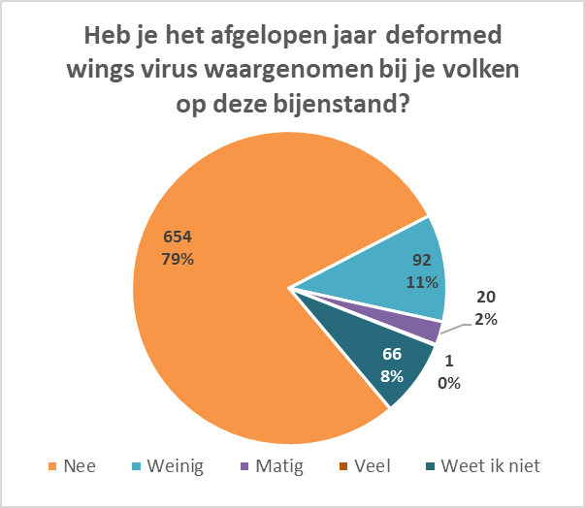

3.8. Assessment of Honey Flow and Pollen
Beekeepers rated honey flow and pollen availability across different seasons on a scale of 1 to 7. Pollen availability peaked in the spring (averaging 5.14) and saw a gradual decrease through the summer (4.86) into late summer (4.54). In contrast, honey flow remained relatively stable across spring (4.65) and summer (4.81), but experienced a sharper drop in the late summer season (3.78).
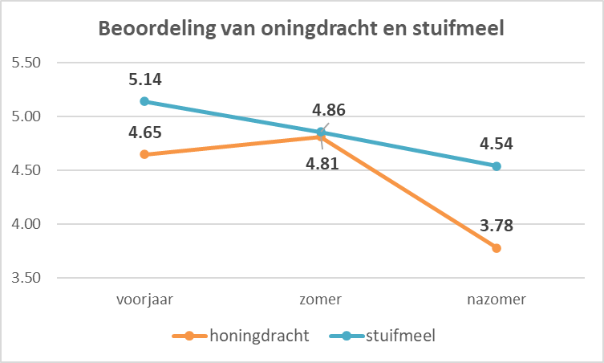

4. Analysis of Factors Affecting Winter Mortality
This section first examines 5 factors that have a correlation with winter mortality separately: beekeeping method, winter feed, observed varroa existence, varroa treatment, and observed asian hornet existence. Afterwards, a regression model is used to determine the actual impact of the aforementioned beekeeping practice factors (beekeeping method, winter feed, and varroa treatment). This allows us to see which factors remain as the primary drivers of mortality when all of them are analyzed together.

4.1. Beekeeping method: controlled method relates with lower mortality
In the questionnaire we asked beekeepers to self-report the beekeeping method they are using, and grouped the answers into four categories: controlled methods, natural methods, regulier methods, and other unknown or mixed methods .These were treated as ordinal data, dummy-coded to be 4 categories.
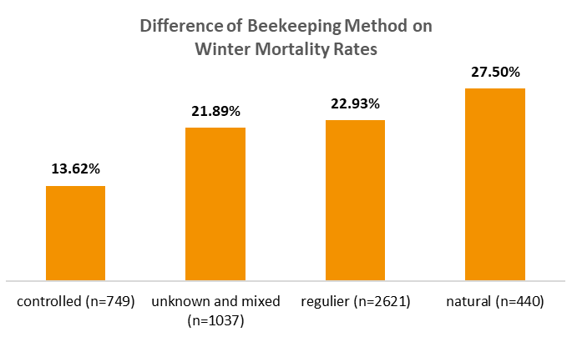
*Note: ‘n’ is the number of hives at the beginning of winter.

The death rate from controlled beekeeping methods is significantly lower than all the other categories. The former has a death rate of 13.62%, while the other 3 categories all have a death rate over 20%. Controlled methods mainly include aalster method and renson method, which are production-oriented, human-centric beekeeping approaches that prioritize commercial stability and honey harvest.

4.2. Winter feed (honey or sugar): feeding only honey results in high mortality
To investigate the effect of winter feed, we categorized the feeding types into three levels: exclusively sugar (water), a combination of honey and sugar (water) (or other kinds of feeding), and exclusively own honey.
These were treated as ordinal data, dummy-coded to be 3 categories. In this scale, a higher value represents a higher proportion of natural honey, which we hypothesize may correlate with higher mortality rates.

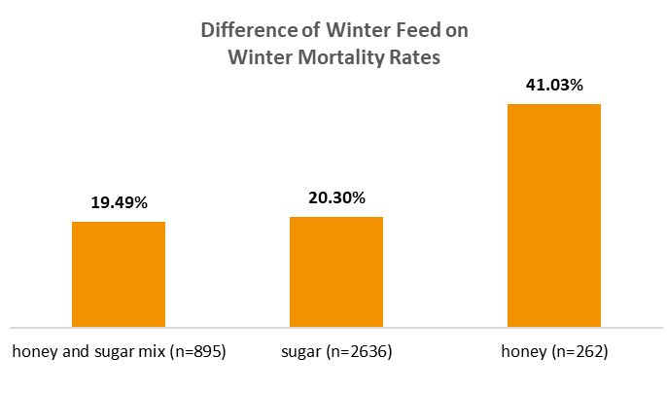
*Note: ‘n’ is the number of hives at the beginning of winter.

We found a significant difference in the death rate between different type of winter feed: using only honey presents a higher death rate than the other two practices that include sugar (water), and statistical testing confirms that this difference is highly meaningful and not just the result of random chance. Hives wintered only on honey experienced a strikingly high mortality rate of 41.12%. In contrast, those fed with sugar water (either exclusively or combined with honey) showed significantly lower mortality rate of around 20%. This suggests that natural honey stores may have contained accumulated toxicity that endangered bees.
Last year, our results indicated an increase in the death rate as long as honey was included in the winter feed, however, this trend is no longer the same this year. This change will be one of the focuses for investigation in our future analysis.

4.3. Observed Varroa: not observing varroa suggests even higher mortality rates
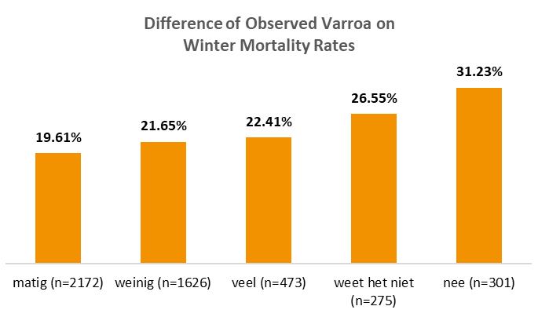
*Note: ‘n’ is the number of hives at the beginning of winter.

Our questionnaire asked about if the beekeepers have observed varroa mites in and around their apiaries. The results show that the group reporting not seeing varroa mites actually has the highest mortality rate of 31.23%, while the group reporting moderate varroa has the lowest death rate of 19.61%. Therefore, a conclusion we draw from this result is that not seeing does not equal to not existing.

4.4. Varroa treatment: treatment is important, but timing as well.
Varroa treatment strategies were categorized based on the timing and completeness of the intervention, ranging from a full ‘3-course’ treatment and alternative treatments to partial treatments and no treatment at all.
Given that these methods do not follow a linear progression in terms of biological impact, this variable is dummy-coded into 5 categories.

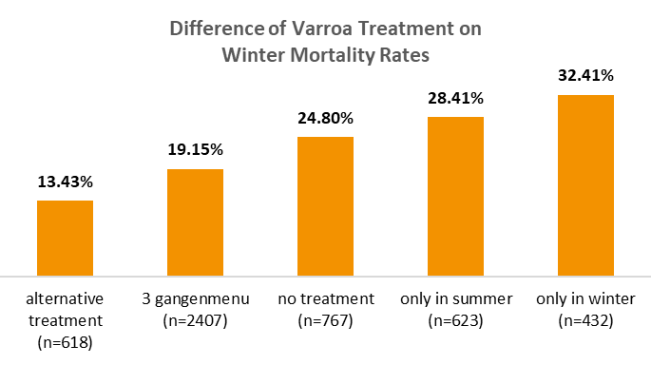*Note: ‘n’ is the number of hives at the beginning of winter.

The alternative complete treatments (13.43%) and ‘3 gangenmenu’ (19.15%) resulted in the lowest mortality. Doing such two types of treatment significantly lowers the mortality rate than the other three methods.
Interestingly, both treatments ‘only in winter’ (32.41%) and ‘only in summer’ (28.41%) showed higher mortality than ‘no treatment’ (24.80%).This implies that proper treatment could effectively lower the mortality rate, while treating only in one of the seasons is not effective.

4.5. What does beekeeping method entail: natural beekeepers tend to rely less on sugar water and don’t treat against varroa
Our previous part of the analysis has already found out that those using natural beekeeping methods carry a higher death rate. However, this is partly due to the choice of winter feed and varroa treatment, instead of the method itself.
The two graphs below show the distribution of winter feed and varroa treatment across different groups of beekeeping methods. It clearly reveals that among all groups, beekeepers using natural methods tend to feed bees with only honey during winter, and give no treatment against varroa.
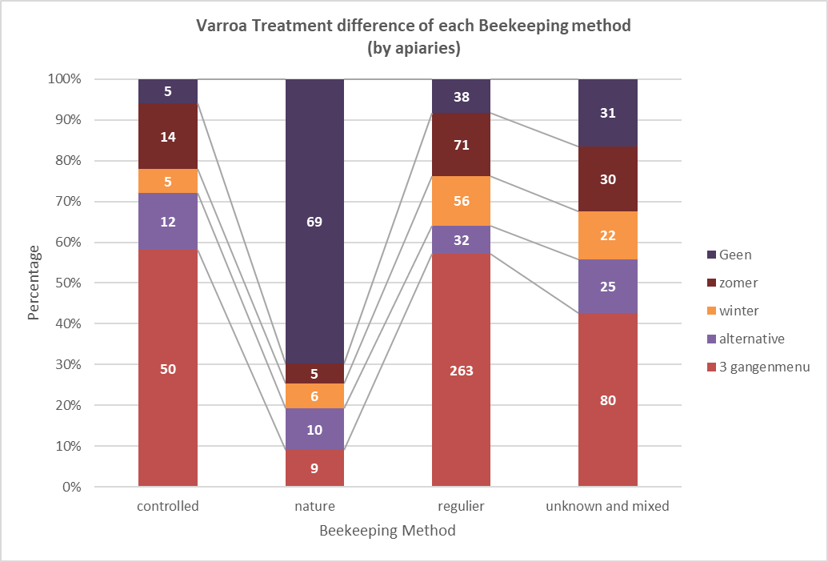
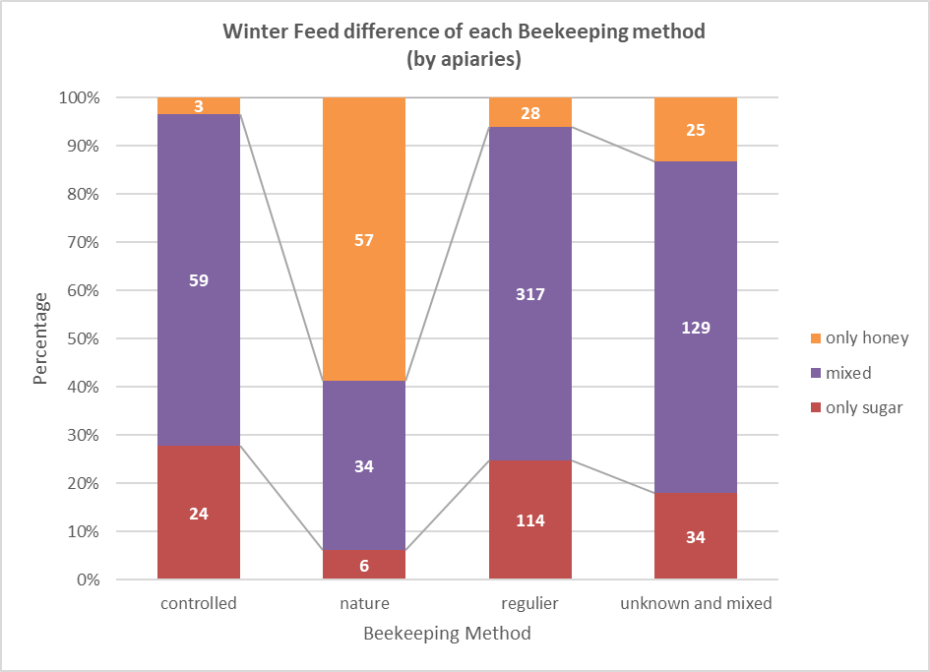
In the later part of our analysis, we also proved a similar point using regression model: when all the other factors are controlled, natural beekeeping method does not carry a higher mortality risk than controlled method (i.e. two beekeepers are doing everything else in the same way, but one uses a controlled beekeeping method, the other one uses a natural beekeeping method, then the death rate of their hives will likely be very similar.). Another interesting finding in that part is that when all the other factors are controlled, regulier beekeeping method carries 50% higher mortality risk than controlled method.

4.6. Aziatische hoornaar

The group that observed ‘matig’ and ‘veel’ asian hornet has the lowest average death rate, while the group reporting not observing any asian hornet keeps a higher average death rate of 25.94%. It suggests a similar pattern with varroa mites: not seeing does not equal to not existing.
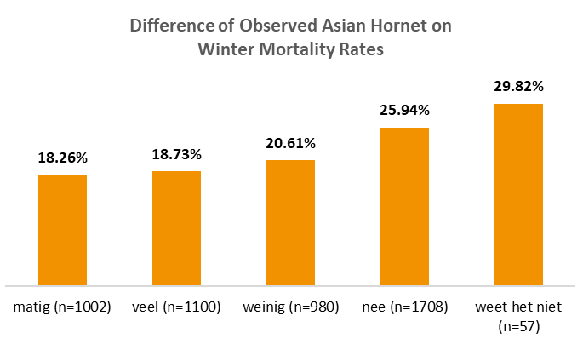
*Note: ‘n’ is the number of hives at the beginning of winter.

4.7. Other Diseases and Mites
We had also asked the beekeepers if they have observed other diseases during the year. Some common answers we received include: Chronic Bee Paralysis Virus (CBPV), European Foulbrood and Chalkbrood (Kalkbroed), occasionally linking these to poor queen development or the suspected presence of Black Queen Cell Virus. Other concerns included suspected Nosema and widespread instances of dysentery (roer), which was often noted on hive exteriors or following early spring cleansing flights.
Beyond viral and bacterial issues, varroa mites were also reported by beekeepers multiple times in this open-ended section, with many respondents observing symptoms like K-wings (Kreukelvleugelsvirus) or the presence of unusually small bees. Moreover, the feedback highlighted various external pressures such as pesticide damage (spuitschade) during fruit bloom periods, the presence of large hornet nests near apiaries, and ants nesting within double-walled hive structures.

4.8. Which factors are truly effective, and how much impact does each factor carry: A result from the regression model.
While previous analysis presents the difference of death rate between categories, it doesn’t analyze how strong a correlation is. Moreover, for combined effects (the effect combining varroa treatment and winter food), it doesn’t show if the difference between groups are statistically significant. A regression analysis would help solve this issue.
The regression model I choose is the Generalized Estimating Equations (GEE) model. This specific model (GEE) was selected to address the clustering of hives in the same apiary. Traditional logistic regression models assume that all hives are completely independent, however, in reality, hives in the same apiary share identical microclimates and beekeeping practices, making them inherently correlated. By utilizing a GEE framework, we robustly corrected for this apiary-level clustering, preventing the underestimation of standard errors and avoiding false-positive conclusions. This modeling approach allows us to cut through the noise of individual beekeeper habits to isolate the true, unbiased impact of specific beekeeping choices.
Building on the result from previous analysis, I set the baseline of the regression model as: controlled beekeeping method, feeding a mix of honey and sugar water, and alternative complete varroa treatments.
There are four models conducted:
Model 1: a baseline model with 2 variables: winter feed and varroa treatment.
Model 2: a subsequent model including the interaction between winter feed and varroa treatment.
Model 3: a baseline model with 3 variables: winter feed, varroa treatment, and beekeeping method.
Model 4: a subsequent model including the interaction between winter feed and varroa treatment.
The two baseline models evaluate variables independently, operating under the assumption that their impacts on hive mortality simply adds to top of each other. However, biological systems rarely operate in isolation. Therefore, the second and the fourth model introduced interaction terms to test whether the combined effect of two management practices is fundamentally different from the simple sum of their individual risks.

The models draws the following conclusions:
The following factors carry more risk of death compared with baseline practices: using regulier beekeeping method, feeding honey during winter, treating varroa only in the summer, and no varroa treatment.
Model 3 suggested the beekeeping practices have an impact on hive mortality. When all the other factors are controlled, the regulier method still carries 50.81% higher mortality risk compared to the controlled method baseline.
Comparing the result of model 1 and model 3, it can be concluded that certain practices have an impact on hive mortality. When all the other factors are controlled, feeding honey during winter carries a 60% ~ 75% higher mortality risk compared to the mixed honey and sugar water baseline. No varroa treatment and treatment only in summer carries a doubled mortality risk compared to alternatieve behandeling.

Comparing model 3 and model 4, there is a pattern that can be concluded from the Odds Ratio of the interactions: although certain beekeeping practices are concerning, their combination doesn’t affect its scale of impact on mortality in a linear way. There is a diminishing marginal impact.

4.9. Combining varroa treatment and winter food
We are also most interested in the difference in mortality rate of different combinations of winter food and varroa treatment. The heatmap descriptively shows the mortality difference.
Among all possible combinations, the group with ‘only honey during winter’ has the highest death rate, except for the hives using a ‘3 gangenmenu’ varroa treatment at the same time.
‘Honey only' and ‘no varroa treatment’ showed a death rate of 45.4%. In comparison, ‘sugar only’ and ‘3 gangenmenu’ varroa treatment showed a death rate of 19.4%, which is greatly lower.

Combining the regression model with the heatmap, it allows us to determine if the difference in death rate carries any statistical significance.
When feeding only honey, the winter-only treatment seems less effective than the summer-only treatment, but this difference is not significant.
An exciting finding is that even if bees are fed on only honey during winter, as long as they are treated against varroa with 3 gangenmenu, the drop in mortality rate (from 45,4% to 16,3%) is significant compared to other 4 possible combinations. This again emphasizes the impact of proper varroa treatment in lowering death.
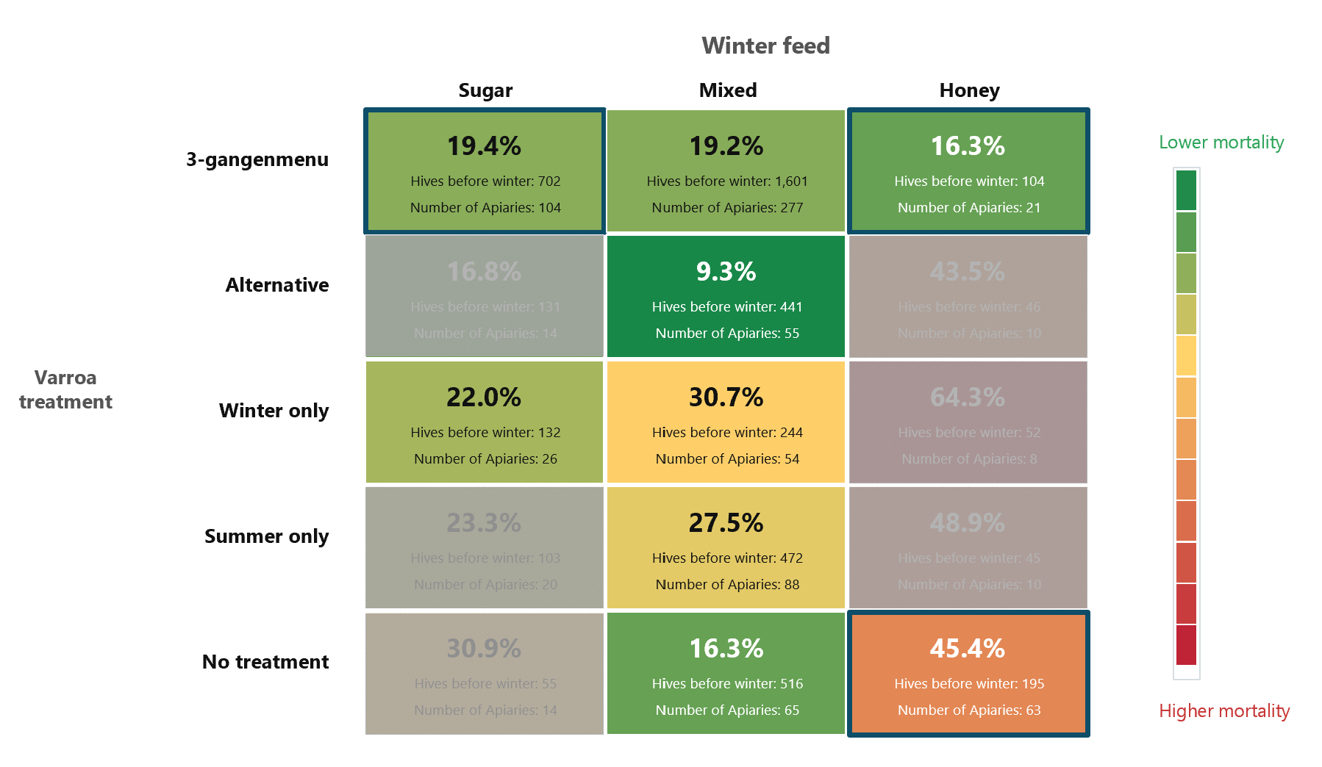

5. Conclusion
The 2025-2026 winter season confirms that honeybee mortality in the Netherlands remains at an alarmingly high level. With an overall loss rate of 21.69%, the data underscores that environmental pressures and specific beekeeping choices are influencing colony survival to a great extent.
Our statistical modeling reveals that passive or unmonitored management approaches pose the greatest risk to bees. The highest mortality rates were consistently found among apiaries where beekeepers relied solely on natural honey as winter feed, or where Varroa mites and Asian hornets went unnoticed and untreated. Conversely, proactive interventions, including supplementing winter feed with sugar water and administering complete varroa treatments like the ‘3-gangenmenu serve as highly effective protective practices, even mitigating the risks associated with other factors.
Moving forward, these findings highlight that emphasizing proactive pest monitoring, rather than assuming absence when pests are not immediately visible, and encouraging strategic winter feeding could substantially reduce future winter losses.

Appendix

Link to the survey:

https://app.formbricks.com/environments/cmk4775is8p8ead01d6uk33ow/surveys/cmkbibhk69hohad01t13iqs8d/summary?referer=true
https://docs.google.com/document/d/19fNeGK6ufE2Ipf6e1StW3lgc7iy2z50FV9FWAzZc4UU/edit?tab=t.0#heading=h.2yjxr1umsg35

Deleted data entries:
Location not in the Netherlands: 3 entries
Abnormal growth during winter: 9 entries

Data cleansing and coding:
Words in bold are original options

Q4. Welke imkermethode hanteer je?
1: Aalster methode; AANGEPASTE AALSTER; Renson methode; Darrenraatmethode; KI; Breek zwermcellen; VSH focus BeeBreed; Arrest methode
2: Biodynamisch imkeren; Korfimkeren; Natuurlijk imkeren; Natuurvriendelijk imkeren; Darwiniaans imkeren; Biologisch met SKAL certificaat; Topkasten; Ongeregelde bijenkorf; Zwermen afwachten; Niet volledig BD, maar sterke invloeden hieruit
3: Ik imker regulier; Eenbaks imkeren; Liebig; Methode Aumeier; Golzkasten; op een broedkamer in warmbouw; Golz; Broedaflegger
4: Weet ik niet; Ik gebruik geen specifieke methode; +mixed methods; Natuurbouwkast en gangbare spaarkast. beide. Zwermen en geen behandeling varia; Topkasten met arrestraammethode; In de verenigingshal doen de leden ieder hun eigen ding; Geleerd van imkerij Drakenbijen;
Dummy Coding

Q19. Hoe was de ontwikkeling van de volken tijdens het voorjaar en zomer 2025 op deze bijenstand?
1: Overwegend goed; Ik had geen dode volken; heel goed; uitzonderlijk goed
2: Overwegend matig; Langzaam
3: Overwegend slecht
4: Nvt

Q20. Hoe heb je de bijen ingewinterd?
1: Uitsluitend op suikerwater(bijenvoer); suikerwater (1 deel water, 2 delen suiker) met kruidenthee (kamille, heermoes, duizendblad).
2: Combinatie van eigen honing en suikerwater(bijenvoer); Combinatie eigen honing met invertsuiker; Eigen honing (ik slinger niet), aangevuld met suiker vanwege drachtarmoede op platteland; Eigen honing in kast aangevuld met kruidentheesuierwater; Een van de combinaties hierboven en extra eiwitten; Eigen honing en BeeElixer aangevuld met kruiden zoals kamille en goudsbloem; Fondant toegevoegd op 30-1-26. Ik heb daar nu spijt van; 3 volken met suiker ingewinterd, rest had in de Biesbosch voldoende voer in de onderbak. Op suiker en honing maakt geen verschil bijna alles goed in het voorjaar; Eigen honing, suikerwater met etherische oliën.
3: Uitsluitend op eigen honing, Combinatie van eigen honing en honing van andere volken; was voldoende zowiezo geen honing afgenomen; Ik geef geen voer. Ik neem ook geen honing af. Ik imker met korven; Voor 90% op eigen honing; Met suikerwater maar ben gestopt toen ik ontdekte dat er nog erg laat (tot eind september) dracht binnen kwam
Ordinal (1-lower death)

Q21. Heb je het afgelopen jaar varroa waargenomen bij je eigen volken op deze bijenstand ?
1: Ja, veel
2: Ja, matig
sommige volgen veel, sommige volken weinig
Ja, maar hoeveel? geen idee.
Sommige volken wel, andere niet
3: Ja, weinig
Uiteraard nog last van mijten, maar onze teelt is volledig gericht op VSH met o.a. KI, waardoor bij 60% van de volken de mijtentelling uit kwam onder 1%
alleen op de varroa lade
Een volk behandeld met mierenzuur en in de herfst alles gesubsidieerd
4: Nee, geen varroa waargenomen
5: Weet ik niet, ik heb er niet op gelet
ik doe mee aan het WUR project, Weerbare bijen - Darwin Methode

Q22. Zijn de bijen het afgelopen jaar tegen varroamijt behandeld op deze bijenstand?
1: Ja, volledige behandeling met 3 gangenmenu
2: Ja, alternatieve behandeling
3: Ja, gedeeltelijke behandeling alleen in de winter
4: Ja, gedeeltelijke behandeling alleen in de zomer
5: Nee
Dummy Coding

Q23. Heb je het afgelopen jaar Aziatische hoornaars waargenomen bij je volken op deze bijenstand ?
1: Ja veel, er zijn er vaak meer dan 3 voor de kast te zien
2: Ja matig, vaak minstens 1 voor de kast
3: Ja weinig, af en toe 1
We hebben er 1 gezien, die voor de kast heen en weer vloog. wij stonden te kijken wat erzou gebeuren en ineens vloog hij met een zwaai door de lucht. Hij werd weggevoerd door 3 bijen al vechtend. Zeker 1 bij liet hierbij het leven. De hoornaar hebben we niet weergezien.
1 dode hoornaar
In het voorjaar 1 koningin en gevangen.
Wel op 200 mtr afstand een beginnend nest verwijderd
Zat wel een nest op 100 meter van waar mijn kast staat
Veel Europese hoornaars,en eenenkele Aziaat
in april heb ik 1 AH koningin gevangen en doorgegeven op waarneming.nl
Bij de kast een enkele gezien/ gevangen. Echter de bijen bleven bij de kast hangen en gingen er mid zomer er niet op uit, ookal was het 25 graden. Later hebben we een nest gevonden 500 meter verder op. Ik vermoed dat de bijen in de open lucht er wel laat van hadden en daarom besloten thuis te blijven.
4: Nee, geen Aziatische hoornaar waargenomen
Veel wespen, hommelnest, Hoornaar gezien (kon niet zien of deze Europees of Aziatisch was.)
Wel veel Europese Hoornaars die bijen pakten
niet direct bijh het volg zelf AG gezien, maar er waren waarnemingen in de omgeving
Dit jaar voor het eerst veel last van actief prederende Europese hoornaars
5: Weet ik niet
ik begin net we gaan het dit jaar zien
Dummy Coding

24. Heb je het afgelopen jaar deformed wings virus waargenomen bij je volken op deze bijenstand?
1: Ja, veel
2: Ja, matig
3: Ja, weinig
4: Nee, geen deformed wings waargenomen
5: Weet ik niet

Difference of mortality among categories:
============================================================
ANALYSIS: Beekeeping method
============================================================
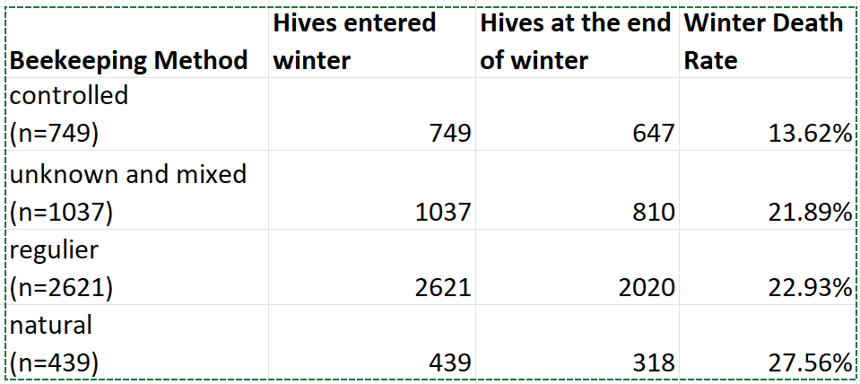
--- 1. Global Chi-Square Test ---
Global P-Value: 0.00000
✅ SIGNIFICANT: There is a statistically significant difference in mortality rates between the categories of this variable.
--- 2. Pairwise Comparisons (Post-hoc) ---
💡 Statistical Rigor: Because we are making 6 pairwise comparisons, we applied a Bonferroni correction to avoid false positives. The adjusted significance threshold is P < 0.0083
⭐ Significant Difference: Controlled vs Natural | P-Value: 0.00000
⭐ Significant Difference: Controlled vs Regulier | P-Value: 0.00000
⭐ Significant Difference: Controlled vs Unknown and Mixed | P-Value: 0.00001
No Significant Difference: Natural vs Regulier | P-Value: 0.03988
No Significant Difference: Natural vs Unknown and Mixed | P-Value: 0.02262
No Significant Difference: Regulier vs Unknown and Mixed | P-Value: 0.52629

============================================================
ANALYSIS: Winter Feed
============================================================
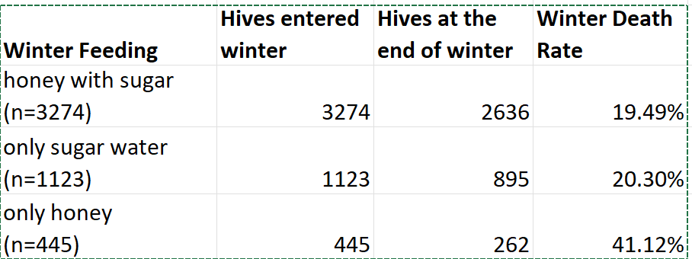

--- 1. Global Chi-Square Test ---
Global P-Value: 0.00000
✅ SIGNIFICANT: There is a statistically significant difference in mortality rates between the categories of this variable.
--- 2. Pairwise Comparisons (Post-hoc) ---
💡 Statistical Rigor: Because we are making 3 pairwise comparisons, we applied a Bonferroni correction to avoid false positives. The adjusted significance threshold is P < 0.0167
No Significant Difference: Sugar vs Mixed | P-Value: 0.58248
⭐ Significant Difference: Sugar vs Honey | P-Value: 0.00000
⭐ Significant Difference: Mixed vs Honey | P-Value: 0.00000

============================================================
ANALYSIS: VARROA TREATMENT
============================================================
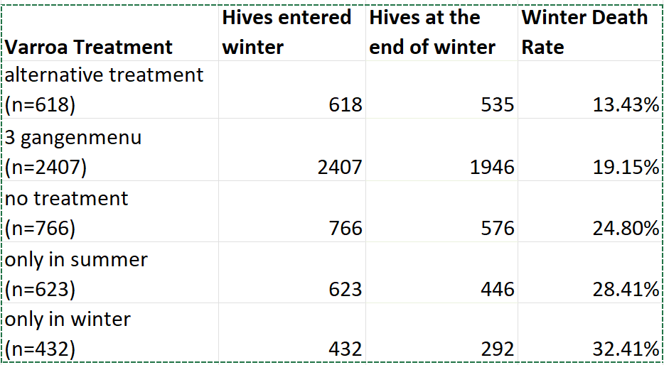
--- 1. Global Chi-Square Test ---
Global P-Value: 0.00000
✅ SIGNIFICANT: There is a statistically significant difference in mortality rates between the categories of this variable.
--- 2. Pairwise Comparisons (Post-hoc) ---
💡 Statistical Rigor: Because we are making 10 pairwise comparisons, we applied a Bonferroni correction to avoid false positives. The adjusted significance threshold is P < 0.0050
⭐ Significant Difference: 3 gangenmenu full treatment vs alternatieve behandeling | P-Value: 0.00117
⭐ Significant Difference: 3 gangenmenu full treatment vs alleen in the winter | P-Value: 0.00000
⭐ Significant Difference: 3 gangenmenu full treatment vs alleen in the zomer | P-Value: 0.00000
⭐ Significant Difference: 3 gangenmenu full treatment vs Nee | P-Value: 0.00089
⭐ Significant Difference: alternatieve behandeling vs alleen in the winter | P-Value: 0.00000
⭐ Significant Difference: alternatieve behandeling vs alleen in the zomer | P-Value: 0.00000
⭐ Significant Difference: alternatieve behandeling vs Nee | P-Value: 0.00000
No Significant Difference: alleen in the winter vs alleen in the zomer | P-Value: 0.18550
No Significant Difference: alleen in the winter vs Nee | P-Value: 0.00576
No Significant Difference: alleen in the zomer vs Nee | P-Value: 0.14565

GEE regression model:
Model 1:
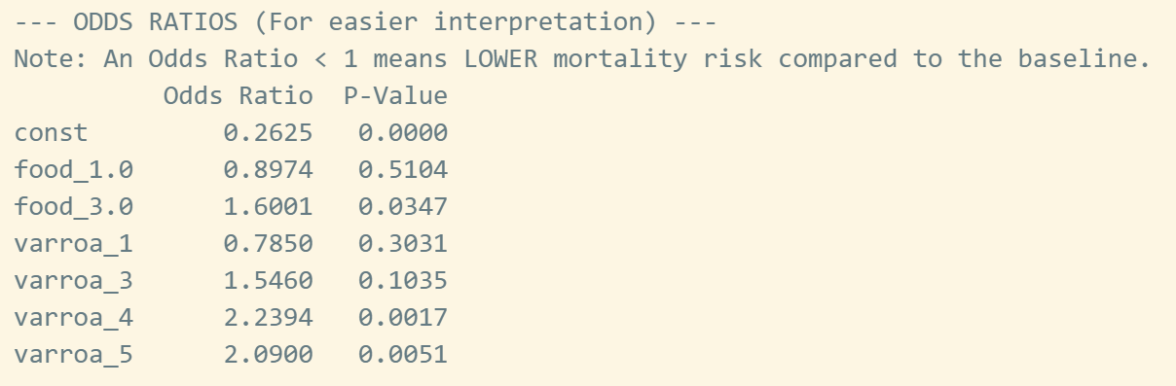

Model 2:
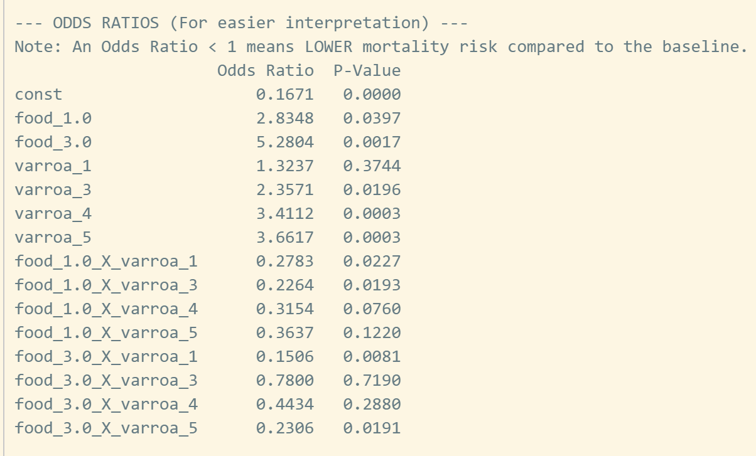

Model 3:
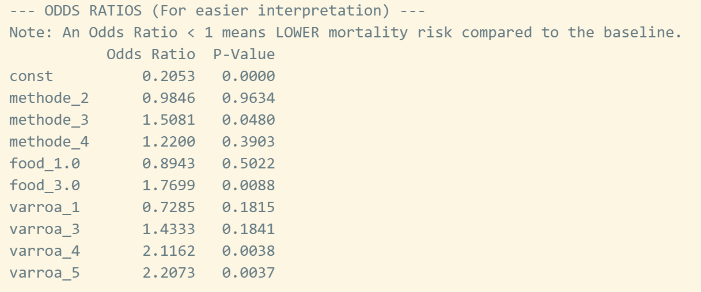

Model 4:
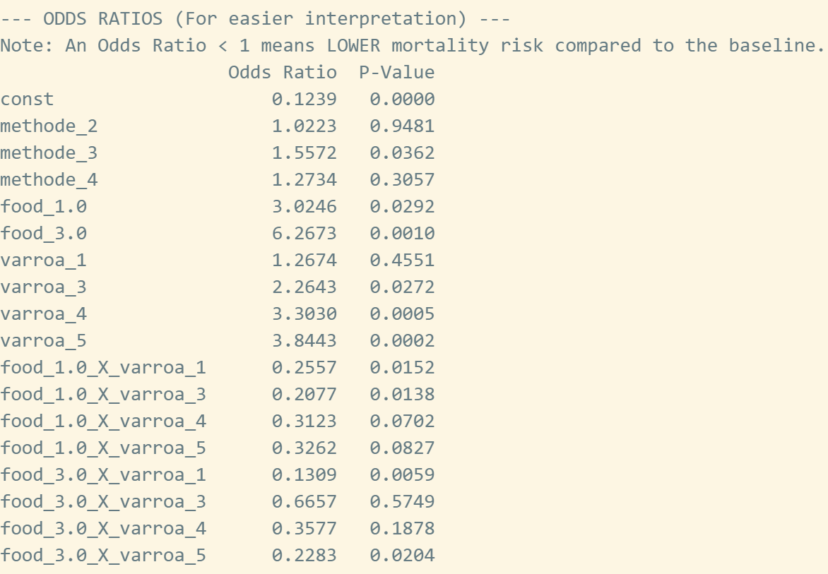

We have compared the previous study by the Bee Foundation and the research of Wageningen on honey bee mortality 2022-2023, and the death rate is likely representative only for provinces with more than 300 hives. However, most provinces in our current survey cover less than 300 hives, which include Gelderland, Noord-Brabant, and Limburg. https://www.bijenhouders.nl/nieuws/wintersterfte-honingbijen-hoogst-sinds-jaren/
A Global Chi-Square test of independence showed a statistically significant relationship between winter feed type and mortality (p = 0.000). For the pairwise comparison, the difference in death rate is statistically significant except for the following groups: no treatment vs only in summer, no treatment vs. only in winter, only in summer vs. only in winter. See appendix for detailed output.
Last year most data were collected between February 12 and March 15. To compare, the data from February 12 to March 15 this year showed a death rate of 21.98%.
A Global Chi-Square test of independence showed a statistically significant relationship between winter feed type and mortality (p = 0.000). For the pairwise comparison, the difference in death rate is statistically significant except for the following groups: sugar vs sugar+water. A p-value under 0.05 indicates we can be over 95% confident in this conclusion. Also see appendix for detailed output.
See appendix for detailed categorization.
A Global Chi-Square test of independence showed a statistically significant relationship between beekeeping methods and mortality (p = 0.000). For the pairwise comparison, the difference in death rate is statistically significant for controlled methods with other methods, but there is no significant difference within those 3 categories. A p-value under 0.05 indicates we can be over 95% confident in this conclusion. Also see appendix for detailed output.
See appendix for detailed output.
If an interaction term is statistically significant (p < 0.05), it indicates that the main effects alone are insufficient to describe the reality. When reading the interaction model, the total risk for a specific combination must be calculated by multiplying the Odds Ratios (OR) of both single factors with the interaction OR. An interaction OR significantly greater than 1 implies that the combination is far more dangerous than expected. Conversely, an interaction OR less than 1 indicates a diminishing marginal impact.

